AD Calendar
# Source: AI Source: Provided by: [Data Path: Persons Table -> ID Column: 1, Name_En Column: Motasem Essam] -> From: [ChatGPT] on [7/17/2026]

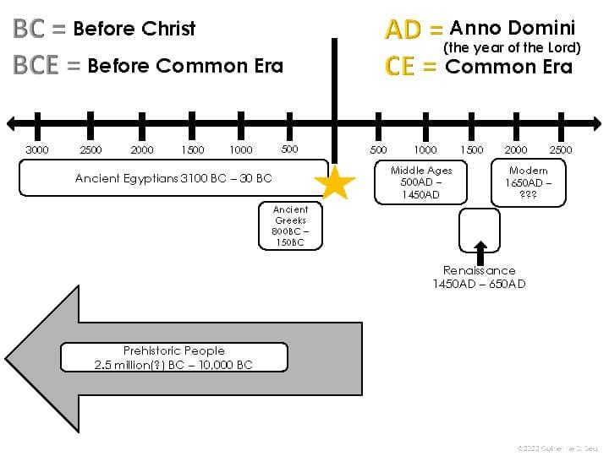
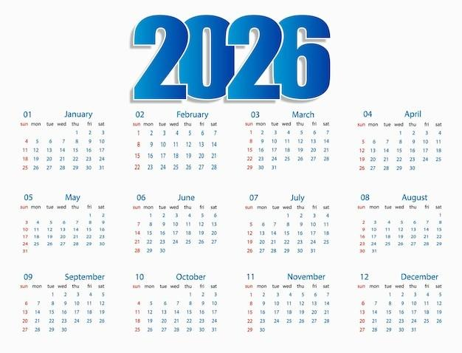
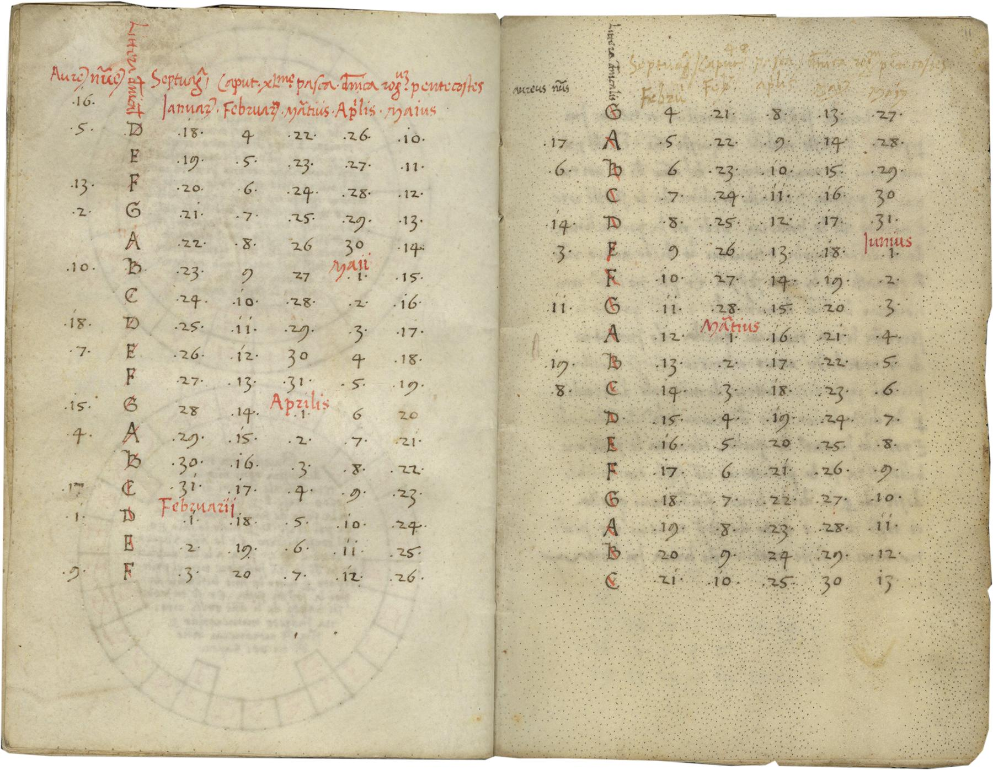
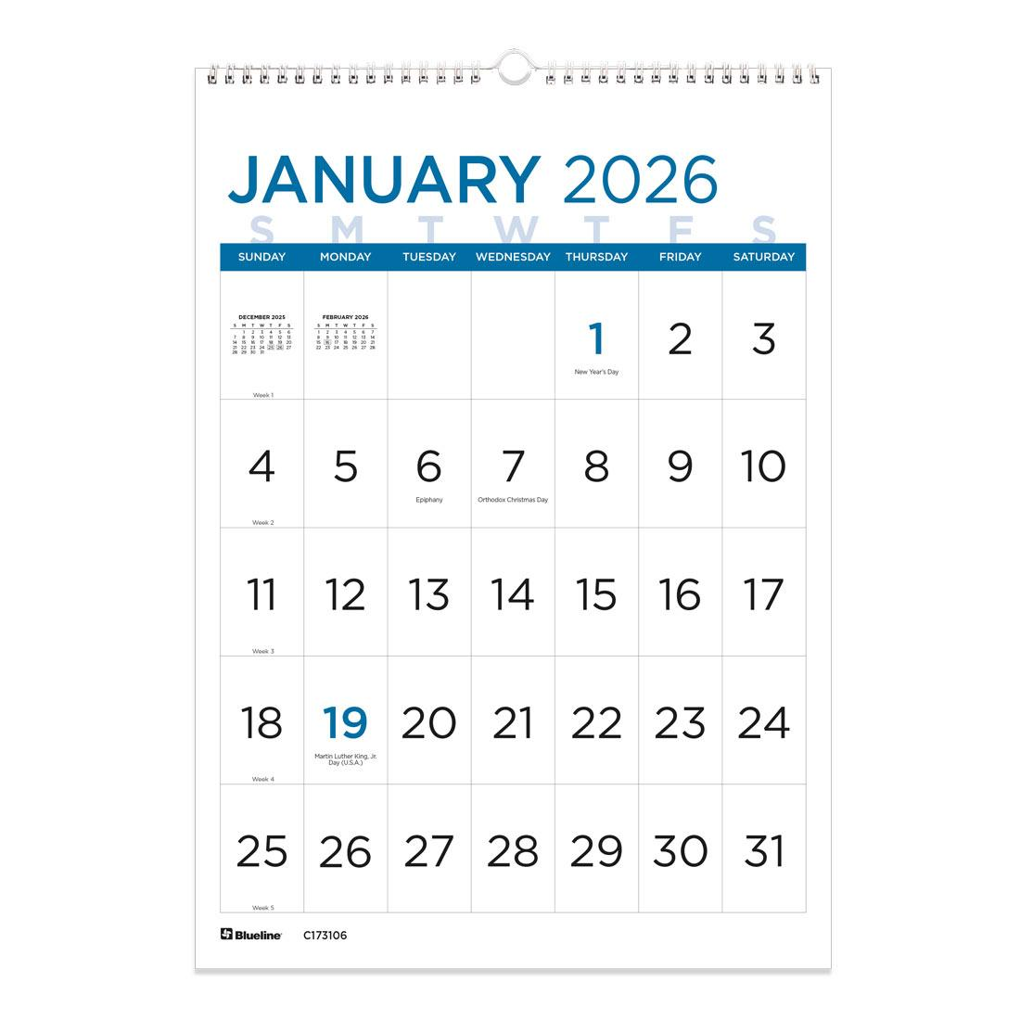
The AD Calendar (short for Anno Domini, Latin for "In the Year of the Lord") is the year-numbering system traditionally used in the Gregorian Calendar and, before that, the Julian Calendar. It counts years beginning with the traditional birth year of Jesus Christ.
Today, the AD system is the most widely used civil year-numbering system in the world, although many academic and international publications prefer the equivalent secular notation CE (Common Era).

Definition
# Source: AI Source: Provided by: [Data Path: Persons Table -> ID Column: 1, Name_En Column: Motasem Essam] -> From: [ChatGPT] on [7/17/2026]
The AD Calendar is a year-numbering system in which years are counted from the traditional year of the birth of Jesus Christ.
"Anno Domini" is Latin for:
"In the Year of the Lord."

Historical Background
# Source: AI Source: Provided by: [Data Path: Persons Table -> ID Column: 1, Name_En Column: Motasem Essam] -> From: [ChatGPT] on [7/17/2026]
- The AD system was introduced by the monk Dionysius Exiguus around AD 525.
- His goal was to number years from the birth of Jesus rather than from the reign of Roman emperors.
- The system gradually spread throughout Europe during the Middle Ages.
- After the adoption of the Gregorian Calendar in 1582, the AD numbering system became the international standard for civil dating.

How the AD Calendar Works
# Source: AI Source: Provided by: [Data Path: Persons Table -> ID Column: 1, Name_En Column: Motasem Essam] -> From: [ChatGPT] on [7/17/2026]
The system divides history into two eras:
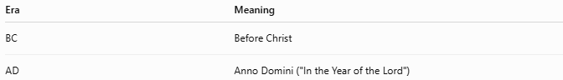
Era | Meaning
BC | Before Christ
AD | Anno Domini ("In the Year of the Lord")
Examples:
- 500 BC
- 1 BC
- AD 1
- AD 2026

No Year Zero
# Source: AI Source: Provided by: [Data Path: Persons Table -> ID Column: 1, Name_En Column: Motasem Essam] -> From: [ChatGPT] on [7/17/2026]
One important feature of the AD system is:
There is no Year 0.
The sequence is:
- 2 BC
- 1 BC
- AD 1
- AD 2
This differs from astronomical year numbering, which includes a year 0.

Relationship to CE/BCE
# Source: AI Source: Provided by: [Data Path: Persons Table -> ID Column: 1, Name_En Column: Motasem Essam] -> From: [ChatGPT] on [7/17/2026]
The year numbers are identical.
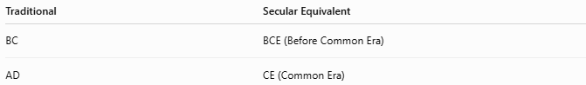
Traditional | Secular Equivalent
BC | BCE (Before Common Era)
AD | CE (Common Era)
Examples:
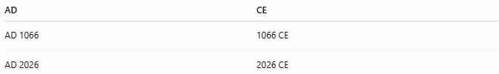
AD | CE
AD 1066 | 1066 CE
AD 2026 | 2026 CE
Only the labels differ.

Calendar Used
# Source: AI Source: Provided by: [Data Path: Persons Table -> ID Column: 1, Name_En Column: Motasem Essam] -> From: [ChatGPT] on [7/17/2026]
The AD numbering system is primarily used with the:
- Gregorian Calendar (modern civil calendar)
Historically, it was also used with the:
- Julian Calendar

Applications
# Source: AI Source: Provided by: [Data Path: Persons Table -> ID Column: 1, Name_En Column: Motasem Essam] -> From: [ChatGPT] on [7/17/2026]
The AD calendar is used in:
- Government records
- Education
- Business
- Banking
- Science
- International trade
- Historical documentation
- Legal documents

Advantages
# Source: AI Source: Provided by: [Data Path: Persons Table -> ID Column: 1, Name_En Column: Motasem Essam] -> From: [ChatGPT] on [7/17/2026]
The AD calendar:
- Is internationally recognized.
- Provides a consistent chronological framework.
- Supports historical documentation.
- Is compatible with the Gregorian Calendar.

Limitations
# Source: AI Source: Provided by: [Data Path: Persons Table -> ID Column: 1, Name_En Column: Motasem Essam] -> From: [ChatGPT] on [7/17/2026]
- The starting point is based on a historical calculation that many scholars believe is not the actual birth year of Jesus.
- The system originally reflects Christian tradition, so some organizations prefer the neutral CE/BCE terminology.

Common Mistakes
# Source: AI Source: Provided by: [Data Path: Persons Table -> ID Column: 1, Name_En Column: Motasem Essam] -> From: [ChatGPT] on [7/17/2026]
- Thinking AD means "After Death."
It actually means Anno Domini ("In the Year of the Lord").
- Writing 2026 AD incorrectly in formal historical style. Traditionally, AD is placed before the year:
  - ✔ AD 2026
  - ✘ 2026 AD (although this is commonly seen today and generally understood)
- Assuming there is a Year 0.

Interesting Facts
# Source: AI Source: Provided by: [Data Path: Persons Table -> ID Column: 1, Name_En Column: Motasem Essam] -> From: [ChatGPT] on [7/17/2026]
- The AD system has been used for over 1,500 years.
- Most countries now use the Gregorian Calendar with AD (or CE) year numbering.
- Scientific and international organizations often prefer CE/BCE, but the year numbers remain exactly the same.

Timeline
# Source: AI Source: Provided by: [Data Path: Persons Table -> ID Column: 1, Name_En Column: Motasem Essam] -> From: [ChatGPT] on [7/17/2026]
2 BC → 1 BC → AD 1 → AD 2 → AD 3 → ... → AD 2026

Comparison with Other Year Numbering Systems
# Source: AI Source: Provided by: [Data Path: Persons Table -> ID Column: 1, Name_En Column: Motasem Essam] -> From: [ChatGPT] on [7/17/2026]
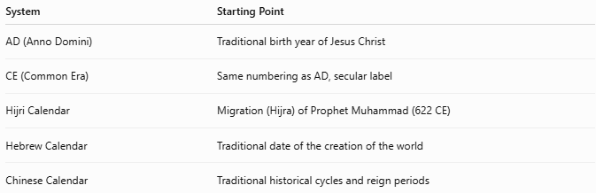
System | Starting Point
AD (Anno Domini) | Traditional birth year of Jesus Christ
CE (Common Era) | Same numbering as AD, secular label
Hijri Calendar | Migration (Hijra) of Prophet Muhammad (622 CE)
Hebrew Calendar | Traditional date of the creation of the world
Chinese Calendar | Traditional historical cycles and reign periods

Key Points
# Source: AI Source: Provided by: [Data Path: Persons Table -> ID Column: 1, Name_En Column: Motasem Essam] -> From: [ChatGPT] on [7/17/2026]
- AD stands for Anno Domini ("In the Year of the Lord").
- It numbers years beginning from the traditional birth year of Jesus Christ.
- It is used primarily with the Gregorian Calendar.
- There is no Year 0.
- AD and CE use identical year numbers.

Conclusion
# Source: AI Source: Provided by: [Data Path: Persons Table -> ID Column: 1, Name_En Column: Motasem Essam] -> From: [ChatGPT] on [7/17/2026]
The AD Calendar (Anno Domini Calendar) is the world's most widely used year-numbering system, forming the basis of modern civil dating in conjunction with the Gregorian Calendar. Beginning with the traditional birth year of Jesus Christ, it provides a continuous chronological framework for historical, legal, scientific, educational, and commercial records. Although many organizations now use the equivalent CE (Common Era) notation, the underlying year numbering remains exactly the same.

